Whyte, Ian (first part from Forest Practices Authority Tasmania website)
BSc Forestry ANU 1968.
A Director of the Forest Practices Authority Tasmania, appointed by the Minister for Infrastructure, Energy and Resources as an independent expert. A person with applied knowledge and expertise in sustainable forest management on private land.
Formerly CEO of the Forest Industries Association of Tasmania and senior advisor to the Tasmanian Farmers and Graziers Association

Passing of Ian Whyte
Email from Richard McCarthy
It is with great sorrow that I am the bearer of sad news with the passing of our good friend and colleague Ian Whyte on the 16th of November 2017, after a long illness due to prostrate cancer. A private funeral will be held on the 22nd of November in Melbourne.
Ian Whyte worked as a forester with Department of Forests before independence. He developed the forestry landowner scheme for the Gogol timber area in Madang besides being involved in numerous forest inventory surveys including assessment of the Bulolo plantations and lectured at the Forestry College. After PNG he joined APPM and then was CEO of the Tasmania Forest Industries Association etc
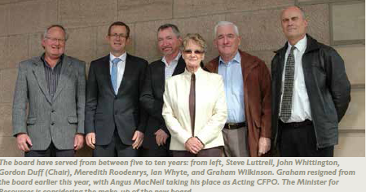2015 photo

